Microsoft Azure - Starter Kits for Partners

Statement of Work (Sample)

Intelligent Apps & Analytics Scenario

Last Update: September 2016





**MICROSOFT MAKES NO WARRANTIES, EXPRESS, IMPLIED OR STATUTORY, AS TO THE INFORMATION IN THIS DOCUMENT.**

The information contained in this document represents the current view of Microsoft Corporation on the issues discussed as of the date of publication. Because Microsoft must respond to changing market conditions, it should not be interpreted to be a commitment on the part of Microsoft, and Microsoft cannot guarantee the accuracy of any information presented after the date of publication.

Complying with all applicable copyright laws is the responsibility of the user. Without limiting the rights under copyright, no part of this document may be reproduced, stored in or introduced into a retrieval system, or transmitted in any form or by any means (electronic, mechanical, photocopying, recording, or otherwise), or for any purpose, without the express written permission of Microsoft Corporation.

Microsoft may have patents, patent applications, trademarks, copyrights, or other intellectual property rights covering subject matter in this document. Except as expressly provided in any written license agreement from Microsoft, the furnishing of this document does not give you any license to these patents, trademarks, copyrights, or other intellectual property.

The descriptions of other companies’ products in this document, if any, are provided only as a convenience to you. Any such references should not be considered an endorsement or support by Microsoft. Microsoft cannot guarantee their accuracy, and the products may change over time. Also, the descriptions are intended as brief highlights to aid understanding, rather than as thorough coverage. For authoritative descriptions of these products, please consult their respective manufacturers.

© 2015 Microsoft Corporation. All rights reserved. Any use or distribution of these materials without express authorization of Microsoft Corp. is strictly prohibited.

Microsoft and Windows are either registered trademarks of Microsoft Corporation in the United States and/or other countries.

The names of actual companies and products mentioned herein may be the trademarks of their respective owners.

Contents

Overview 4

Scenario Overview 6

Why Intelligent Apps & Analytics on Microsoft Azure? 6

The Proposed Solution 7

Azure Infrastructure Estimated Price 8

Fee Schedule 8

Scope of Work 8

Areas Out of Scope 9

Period of Performance 10

Engagement Resources 10

[Company Name] Project Roles and Responsibilities 10

Customer Project Roles and Responsibilities 11

Delivery Methodology 12

Deliverable Materials 12

General Customer Responsibilities and Project Assumptions 13

General Customer Responsibilities 13

Project Assumptions 13

Completion Criteria 14

Conditions of Satisfaction 14

Suggested Sections/Topics to be added by the Partner 14

# Overview

The purpose of this document is to provide Microsoft Partners with a **sample** Statement of Work (SOW) that they can use as a reference to propose to their customers an engagement for deploying an Intelligent Apps & Analytics Scenario.

Although this sample aims at facilitating and accelerating your engagements, Microsoft makes no warranty that using this template will result in a successful project, you are responsible for defining the conditions of satisfaction with your customer and delivering the proposed scenario.

In this document, we cover the following topics:

* SOW CONTRACT TEMPLATE
* THE PROPOSED SOLUTION
* FEE SCHEDULE
* SCOPE OF WORK
* AREAS OUT OF SCOPE
* PERIOD OF PERFORMANCE
* ENGAGEMENT RESOURCES
* DELIVERY METHODOLOGY
* DELIVERABLE MATERIALS
* GENERAL CUSTOMER RESPONSIBILITIES AND PROJECT ASSUMPTIONS
* CONDITIONS OF SATISFACTIOM

|  |  |
| --- | --- |
| [Company Name]  [Company Address] [City, ST ZIP Code] | Logo |

SOW [000] for Agreement to Perform Consulting Services to [Client Name]

Statement of Work

|  |  |  |
| --- | --- | --- |
| Date | Services Performed By: | Services Performed For: |
| [Date] | [Company Name]  [Company Address] [City, ST ZIP Code] | [Client Name]  [Client Address] [City, ST ZIP Code] |

|  |  |
| --- | --- |
|  | Placeholders for your content that appear in the paragraph text are shown in red and will change to the default text color when you add your content. Information that repeats in the document (such as client name) will be updated in all locations when you add or edit it once.  The text provided is sample SOW text that you can edit as applicable for your business.  Note: to delete any tip, such as this one, just click the tip text and then press the spacebar. |

This Statement of Work (SOW) is issued pursuant to the Consultant Services Master Agreement between [Client Name] (“Client”) and [Company Name] (“Contractor”), effective [Click to select date] (the “Agreement”). This SOW is subject to the terms and conditions contained in the Agreement between the parties and is made a part thereof. Any term not otherwise defined herein shall have the meaning specified in the Agreement. In the event of any conflict or inconsistency between the terms of this SOW and the terms of this Agreement, the terms of this SOW shall govern and prevail.

This SOW # [000] (hereinafter called the “SOW”), effective as of [Click to select date], is entered into by and between Contractor and Client, and is subject to the terms and conditions specified below. The Exhibit(s) to this SOW, if any, shall be deemed to be a part hereof. In the event of any inconsistencies between the terms of the body of this SOW and the terms of the Exhibit(s) hereto, the terms of the body of this SOW shall prevail.

In this project, [Company Name] (“Contractor”) will assist you with building an Intelligent Apps & Analytics solution in Microsoft Azure.

This solution delivers an Intelligent Apps & Analytics running in Microsoft Azure. [Company Name] Will assist in the design, deployment, and integration of the solution and leads solution walk through with customer staff.

# Scenario Overview

## Why Intelligent Apps & Analytics on Microsoft Azure?

You can count on Microsoft Azure Infrastructure Services to quickly standup the infrastructure for setup your enterprise data warehouse on the Cloud. You pay for what you use and no more.

Cortana Analytics Suite delivers an end-to-end platform with an integrated and comprehensive set of tools and services to help you build intelligent applications that let you easily take advantage of advanced analytics.

Cortana Analytics Suite provides services to bring data in to analyze it. It provides information management capabilities like Azure Data Factory, so you can pull data from any source (relational DB like SQL or non-relational ones like your Hadoop cluster) in an automated and scheduled way while performing necessary data transforms (like setting certain data columns as dates vs. currency, etc.). Think ETL (Extract, Transform, Load) in the cloud. Event Hubs does the same for IoT-type ingestion of data that streams in from lots of endpoints.

The data brought in then can be persisted in flexible big data storage services like Azure Data Lake and Azure SQL Data Warehouse.

You can use a wide range of analytics services, from Azure Machine Learning to Azure Stream Analytics, to analyze the data that are stored in the big data storage. This means you can create analytics services and models specific to your business needs (say real-time demand forecasting).

The resultant analytics services and models created by taking these steps can then be surfaced as interactive dashboards and visualizations via Power BI in Microsoft Excel.

These same analytics services and models can also be integrated into various UI (web apps or mobile apps or rich client apps) as well as via integrations with Cortana, so end users can naturally interact with them through speech, etc. End users can also be notified proactively by Cortana if the analytics model finds a new anomaly (unusual growth in certain product purchases, in the case of the real-time demand forecasting example given above) or anything that deserves the attention of the business users.

**Summary**:

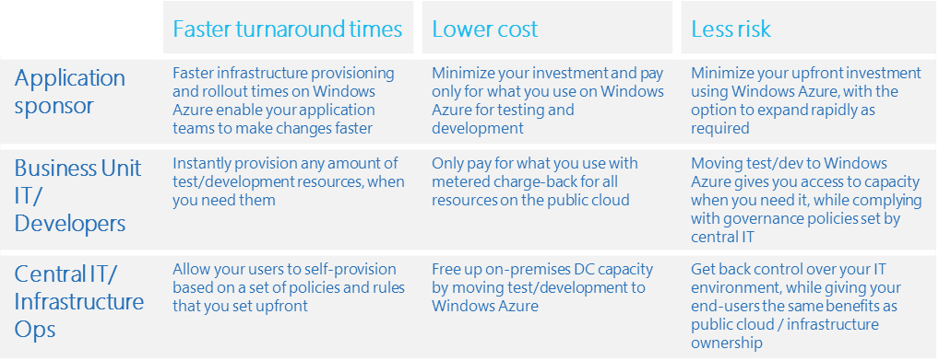

# The Proposed Solution

The scenario illustrated below is purely based on Platform as a Service features like Azure Data Lake Stores, Data Lake Analytics, SQL Data warehouse, Data Factory, Stream Analytics and Power BI. It provides higher agility, scalability and elasticity, which is key for develop new or migrating existing applications to Microsoft Azure.



The rest of this document will discuss the possible architecture aspects for several other scenarios.

## Azure Infrastructure Estimated Price

If your company owns a MSDN subscription, you can enjoy up to $150 in credits on Azure with reduced Windows Server rates and use your MSDN software such as SQL Server for no **additional licensing fee**.

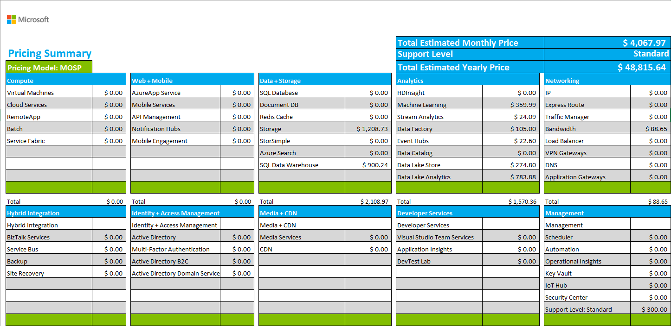

# Fee Schedule

This engagement will be conducted on a Time & Materials basis. The total value for the Services pursuant to this SOW shall not exceed [$000] unless otherwise agreed to by both parties via the project change control procedure, as outlined within. A PCR will be issued specifying the amended value.

# Scope of Work

In this project, [Company Name] (“Contractor”) will assist you with building an Intelligent Apps & Analytics in Microsoft Azure. This solution delivers a development and test lab running in Microsoft Azure. [Company Name] Will assist in the design, deployment, and integration of the solution and leads solution walk through with customer staff.

**Note:** You can leverage Azure as the infrastructure of your Intelligent Apps & Analytics Solution. For this engagement, we are covering Dev and Test infrastructure for several scenarios with Azure Data Lake, Azure SQL Data Warehouse, Azure Machine Learning, Power BI Services, etc.

|  |  |
| --- | --- |
| Work Item | Scope |
| General technical deployment guidance provided by [Company Name] | |
| Activities/Tasks | 1. Envision    * Pre-project preparation    * Project kickoff    * Microsoft Partner Technical Consultant Check-in 2. Plan    * Infrastructure design    * Review of existing Data storage architecture    * Identify report and analytic requirement    * Determine the solution of combination of services 3. Build    * Create SQL Data Warehouse    * Create Power BI    * Create Azure Event Hub    * Create Stream Analytics    * Create Azure Data Factory    * Create Azure Data Lake    * Create Azure SQL Database    * Create Machine Learning Service    * Configuration each service based on the need of the architecture    * Configure Deployment Strategy 4. Test Application    * Test access to application through Browser    * Test Load balancing requirement    * Test Deployment process through PowerShell/TFS 5. Deploy    * Hand off to Operations    * Complete operational transition (configure monitoring, alerting, reporting, and data protection. Perform knowledge transfer and review support)    * Continue turnover operational documentation to customer    * Project close out meeting |

# Areas Out of Scope

Any area that is not explicitly listed in section “Scope of Work” is out of scope for this engagement. The areas that are out of scope for this engagement include, but are not limited to, the following:

* Installation of on premise SQL Server instance or APS
* Overall program and project management.
* Management of customer resources.
* Creation of end-user communications, documentation, training, or change management.
* Application co-existence configuration necessary on the application side.
* Support or assistance for implementing changes to customer identity provisioning processes.
* Technical change management approval process and supporting documentation.
* Microsoft Official Curriculum delivery.
* Write SQL Queries or tune existing queries
* Design Database Schema
* Create Data Factory pipeline
* Develop Custom Machine Learning Algorithm
* Develop Hive, Pig, Spark script for HDInsight
* Design Power BI dashboard, report
* Create Stream analytics job
* Source code implement, debug, test and review
* Integration with 3rd Party Software
* Data warehouse/Data marts
* All aspects of analytic components or capabilities
* Deployment of any components to a production environment
* Data migration from any previously built repository
* Any IaaS components will not be supported
* Assist in configuration or synchronization with AD or AAD
* Anything not identified as in scope

# Period of Performance

The Services shall commence on [Click to select date], and shall continue through [Click to select date].

The total work, including, hands-on activities, technical meetings and answer to e-mails, is limited to a maximum of XXXX hours delivered remotely or on site during the course of the project

# Engagement Resources

### [Company Name] Project Roles and Responsibilities

|  |  |  |
| --- | --- | --- |
| Role | Responsibilities | Project Commitment |
| Engagement Manager | * Responsible for deliverable quality and Customer’s overall satisfaction * Single point of contact for billing issues, personnel matters, contract extensions, and project status * Stakeholder communication issue resolution and escalation | 2 hours / week |
| Solution Architect | * Responsible for overall solution architecture specific to the items identified as in Scope in this document * Verifies that Microsoft recommended practices including technology patterns and implementation strategies are followed | 10 hours / week |
| IT Consultant | * Responsible for planning and execution of solution | 40 hours / week |

### Customer Project Roles and Responsibilities

|  |  |  |
| --- | --- | --- |
| Role | Responsibilities | Typical Time Commitment |
| Customer Project Sponsor | * Makes key project decisions, assists in escalating unresolved issues, and clears project roadblocks | 2 hours / week throughout |
| Customer Project Manager | * Primary point of contact for the whole project * Responsible for managing and coordinating the overall project * Responsible for resource allocation, risk management, project priorities, and communication to executive management * Manages day-to-day activities of the project * Coordinates the activities of the team to deliver deliverables according to the project schedule | Full time during planning; approx. 10 hours |
| Technical Team Lead | * Primary technical point of contact for the team that is responsible for technical architecture and code deliverables | Full time during planning; approx.. 28 hours  Part time during stabilize and deploy phases: approx. 12  4 hours during the Build phase |
| Lead Business | * Primary functional point of contact for the team that is responsible for functional business analysis | Full-time |
| Data Scientist | * Primary technical point of contact for the team that is using machine learning techniques * Responsible for Data mining using state-of-the-art methods * Enhancing data collection procedures to include information that is relevant for building analytic systems | Full time during planning; approx.. 35 hours |
| Data Steward Lead | * Primary technical point of contact for the team that is responsible for processing, cleansing, and verifying the integrity of data used for analysis | Full time during planning; approx.. 20 hours |
| Data Architect | * Responsible for data architecture specific to Stryker developed data warehouse. Collaborates with Microsoft resources on all aspects of data flows and integrations | Full time |
| Developer/SME | * Responsible for the iteration based implementation of integration with third-party device repository including features and remediation and testing of the same. Works with Microsoft resources facilitating on demand data feeds if/as needed | Full time |

# Delivery Methodology

Add here your delivery and project management methodology. Examples of engagement methodologies.

* Scrum
* Microsoft Solution Framework

Explain how you will divide the activities based on your methodology.

# Deliverable Materials

Include any deliverable you may leave behind after the deployment is completed. E.g.

* Documentation for Environment Configuration
* Architecture and Topology Documents
* PowerShell Scripts

# General Customer Responsibilities and Project Assumptions

## General Customer Responsibilities

Delivery of scoped items depends upon, among other things, the following:

* Customer’s involvement in all aspects of the services
* Customer’s ability to provide accurate and complete information, as needed
* Customer’s timely and effective completion of the responsibilities, as identified herein
* The accuracy and completeness of the Assumptions, identified below
* Timely decisions and approvals by Customer’s management
* Customer’s completion of site readiness activities (if applicable)

In addition to any Customer activities identified elsewhere in this SOW, Customer will perform or provide the following:

* Procure and provide access to required Azure subscriptions and capacity
* Provide written descriptions of lab use cases and scenarios
* Provide written diagrams and descriptions of the network topology connecting your datacenter to Azure
* Provide adequate bandwidth to Microsoft Azure
* Make any and all necessary network configuration changes required to facilitate connectivity to Microsoft Azure from your datacenter and the locations from which the lab users will be accessing it
* In performing services under this SOW and the applicable Work Order, Contractor will rely upon any instructions, authorizations, approvals, or other information provided by Customer’s Project Manager or personnel duly designated by Customer’s Project Manager.

## Project Assumptions

The Services, fees, and delivery schedule for this project are based on the following assumptions:

* Customer Experts/Resources will be available as required to support the project service outcomes and timelines
* A project manager is designated for the duration of the project to gather requirements, engage with subject matter experts, and facilitate any resource issues
* All project resources will have the appropriate level of security access required to complete project-related efforts
* All work is to be contiguously scheduled. Any breaks in the engagement calendar must be scheduled four weeks in advance, or will be billed without interruption
* Any and all hardware and software components utilized on-premises are Certified for Windows Server
* All software used in the lab solution is supported for usage in Microsoft Azure by Microsoft and the respective vendor (if produced by a 3rd party)
* Customer’s lab workload performance, capacity, and density patterns follow commonly encountered industry trends or capacity estimates and designs are adjusted to accommodate them
* Customer own or procure all required software licenses and Azure subscriptions
* Customer are responsible for providing an active Microsoft Azure Subscription to be used during the project development
* Customer will provide information about their devices(s) and grant access to stored data on the devices.
* Throughout the project, Contractor will submit requests for decisions or feedback for Customer to complete. Decisions are assigned due dates, and it is assumed that Customer will provide the required feedback or make decisions on either the due date agreed upon or (3) business days from the date of submittal. If a decision or feedback is not provided within the due date or (3) business days, it will be addressed as a potential change of scope pursuant to the Change Management process outlined in this SOW.

# Completion Criteria

The project will be considered complete when any of the following conditions are met:

1. All of the service deliverables identified within this SOW and any Change Requests accepted pursuant to the Change Management Process defined in this document, delivered and accepted or deemed accepted; or
2. All funding has been utilized for hours of services delivered and expenses incurred; or
3. The period of performance has expired; or
4. The Work Order is terminated pursuant to the provisions of the agreement.

# Conditions of Satisfaction

Add here the criteria that define the success of this engagement. E.g.

* Cost of Intelligent Apps & Analytics solution is reduced by X %
* Time spent on implementation and deployment is reducing by X %
* Infrastructure Provisioning time for testing new application features is decreased **by X %**

# Suggested Sections/Topics to be added by the Partner

* Change Management Criteria